Types of Azure Storage Services
Azure Storage provides four main types of services under one Storage Account.

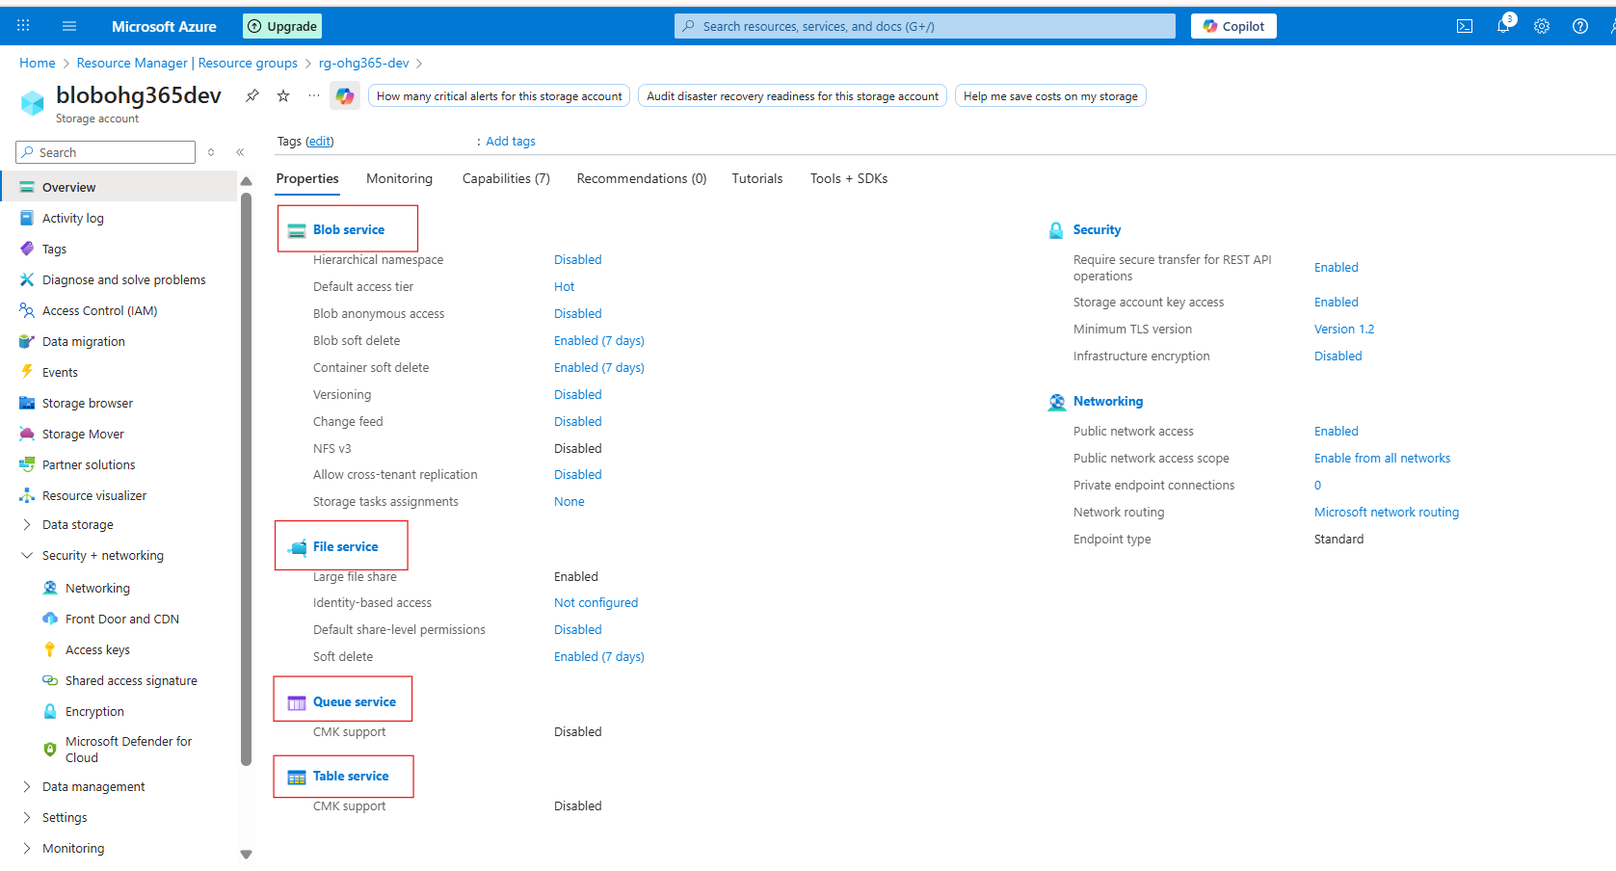

1️⃣ Blob Service
Used to store unstructured or semi-structured data like files, images, videos, logs, and backups.
🔹 Description:
- Stores data as Blobs (Binary Large Objects) inside containers.
- Best for storing flat files and large objects that don’t fit in a database.
- Data can be text, binary, documents, media, or backups.
Example Uses:
- Storing images or videos for websites
- Backups and archives
- Data lake for analytics
- Hosting static websites
Example File Types:
.txt, .csv, .json, .xml, .jpg, .mp4, .zip, .bak

2️⃣ File Service
Used for shared file storage that behaves like a traditional file server.
🔹 Description:
- Provides Azure Files, a fully managed file share in the cloud.
- Uses the SMB (Server Message Block) or NFS (Network File System) protocols the same used by on-premises file servers.
- Can be mounted to Windows, Linux, or macOS systems.
Example Uses:
- Shared network drives for teams
- “Lift and shift” of on-premises file servers
- Application configurations shared across multiple VMs
Example Scenario:
You have multiple virtual machines needing access to the same configuration files. You can store those files in Azure Files and mount them just like a shared folder.

3️⃣ Queue Service
Used for reliable messaging between application components.
🔹 Description:
- Provides asynchronous communication between services using message queues.
- Stores messages in a queue, which can be processed later by background services or workers.
- Ensures messages are delivered at least once and processed in FIFO (First-In, First-Out) order.
Example Uses:
- Sending background jobs (like image processing or email sending)
- Decoupling app components for scalability
- Event-driven architecture
Example Scenario:
A web app uploads an image → sends a message to a queue → a background process picks it up and resizes the image.

4️⃣ Table Service
Used to store large amounts of structured, non-relational data.
🔹 Description:
- Provides NoSQL key-value storage.
- Stores data in tables with entities (rows) and properties (columns).
- Flexible schema you can add or remove columns anytime.
Example Uses:
- Storing user profiles, IoT data, or metadata
- Fast lookups by key
- Lightweight applications needing scalable, cheap storage
Example Scenario:
You have millions of IoT sensors sending temperature data you can store this efficiently in Azure Table Storage.

Storage Service | Type of Data | Description | Example Use Case
Blob Service | Unstructured / Semi-structured | Stores large objects such as files and media | Images, videos, logs
File Service | File-based | Provides shared file storage using SMB/NFS protocols | Shared drives, application configurations
Queue Service | Messaging | Enables message-based communication between application components | Background tasks, event processing
Table Service | Structured (NoSQL) | Schema-less key-value table storage | User profiles, IoT data

Explore Blob Service
Once your storage account is created:
→ Go to your Storage Account
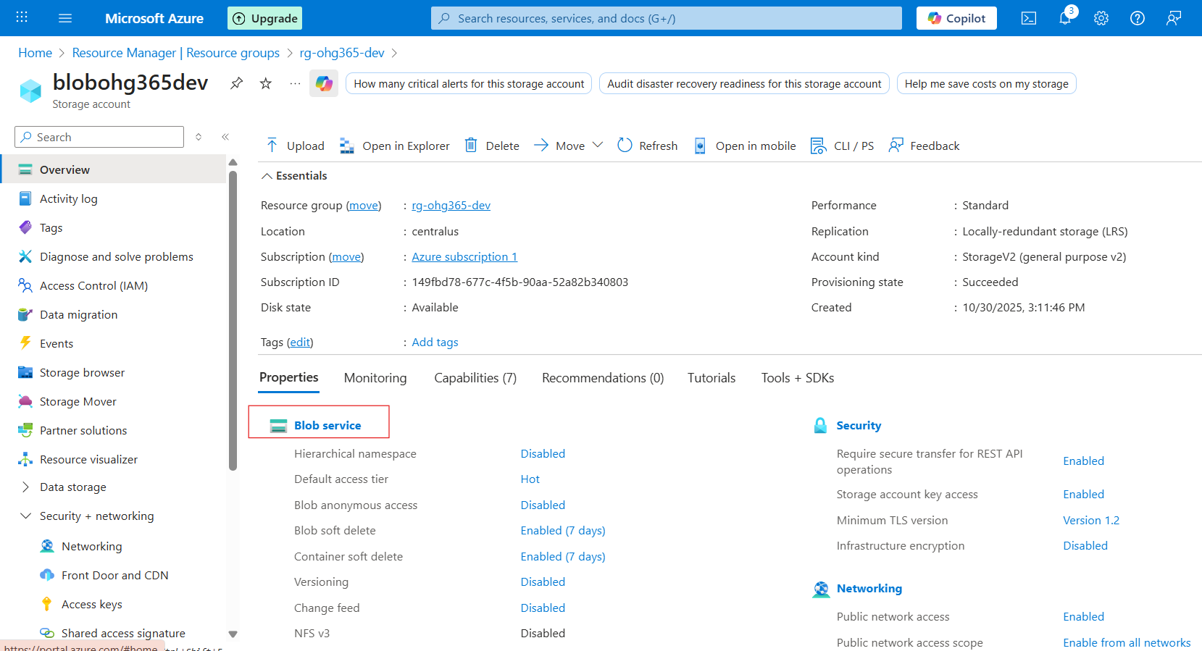

—> Under Data storage, click Containers → This is where your blobs live.
—> Click ➕ Container to create one:
- Name: images, videos, or backups (any name)
- Public access level:
      - Private (default) – Only you can access
      - Blob (anonymous read) – Anyone with the link can read blobs
      - Container (public) – Everyone can see contents

Click on Add container. A new container panel will appear on the right side. Enter the container name and then click the Create button.
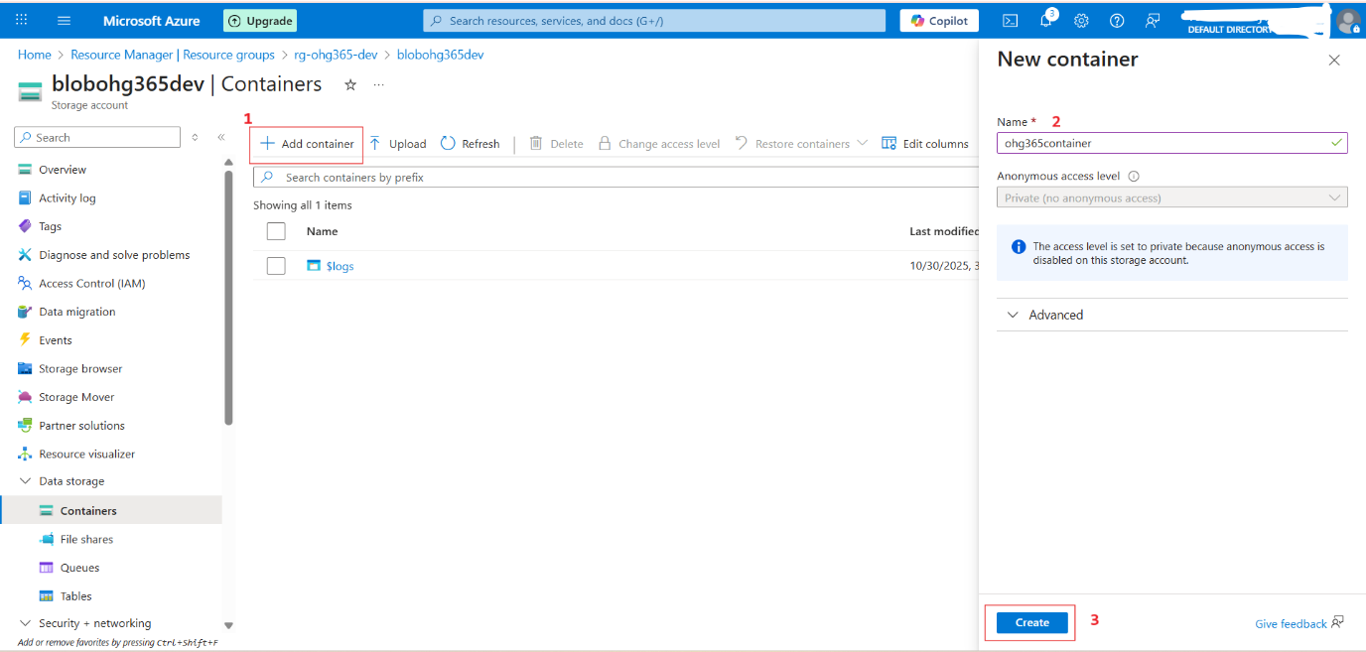

After clicking the Create button, the container section will display the list of container names.

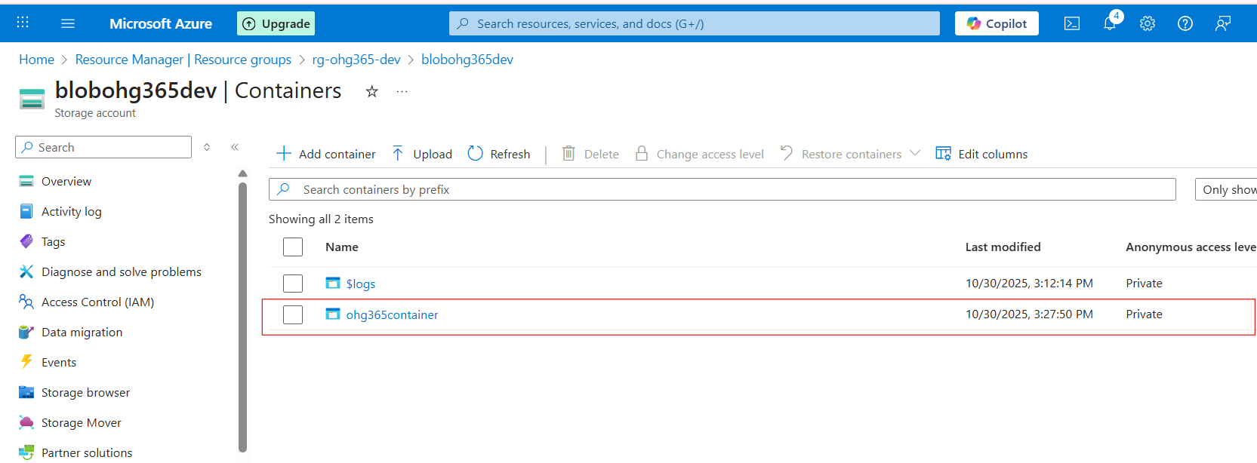

Upload & Manage Blobs
- Click your new container (e.g., images)
- Click Upload
- Choose a file from your computer (like a .jpg, .txt, or .mp4)
- Once uploaded, you can:
  - View Properties (size, type, last modified)
  - Get the URL to access the file
  - Change the access tier

Storage Account
└── Blob Service
└── Container (like a folder)
└── Blob (the actual file)

Click on the Add Directory option here. To create a folder.
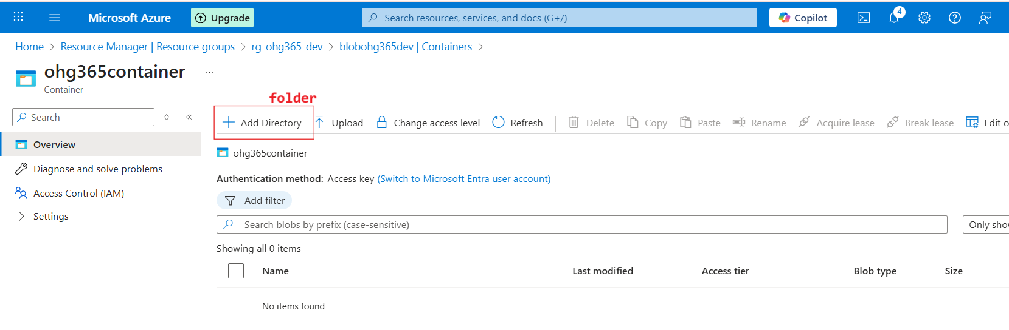
After clicking Add Directory, the Add Virtual Directory panel will appear. Enter the directory name and then click the OK button.

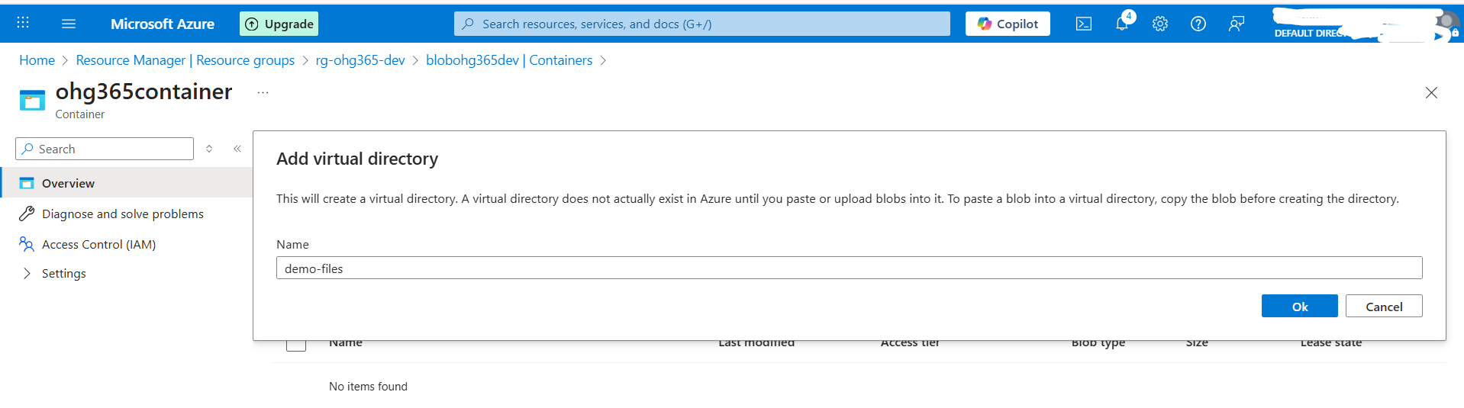
Click on the Upload option here.
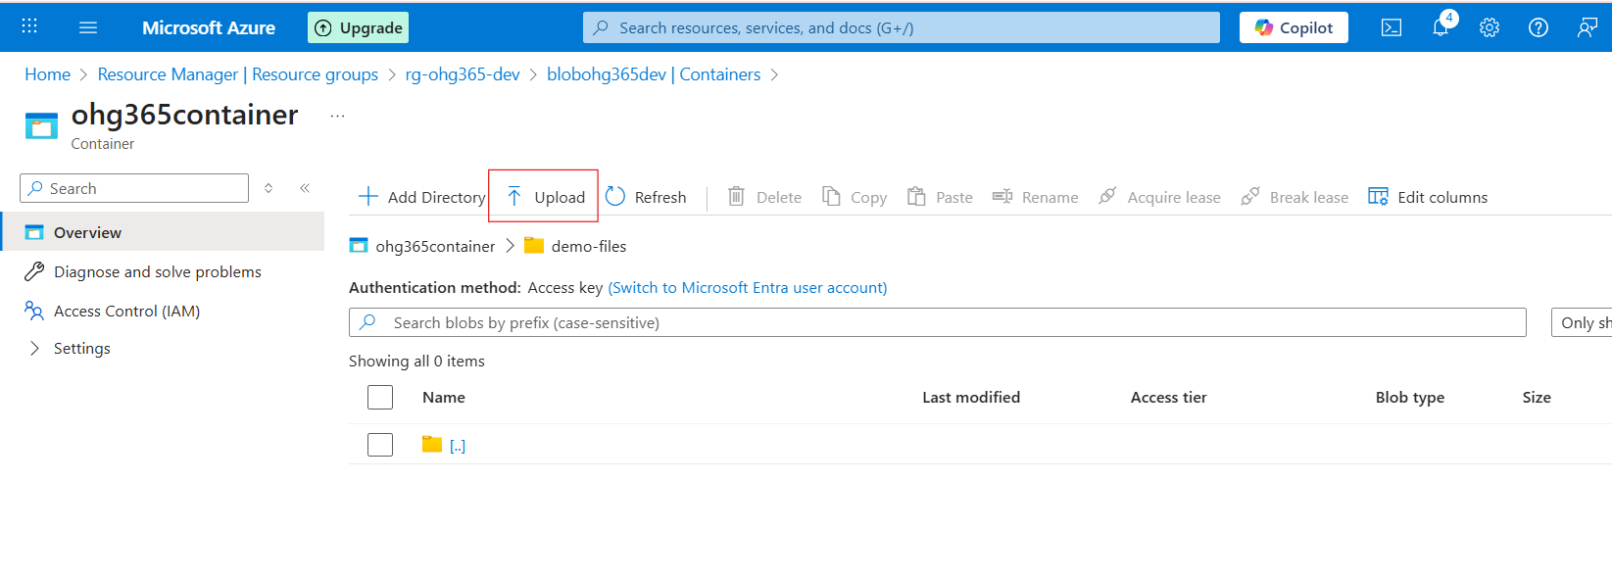
After clicking the Upload option, the Upload Blob panel will appear at the top-right corner. Then click the Browse for files button.

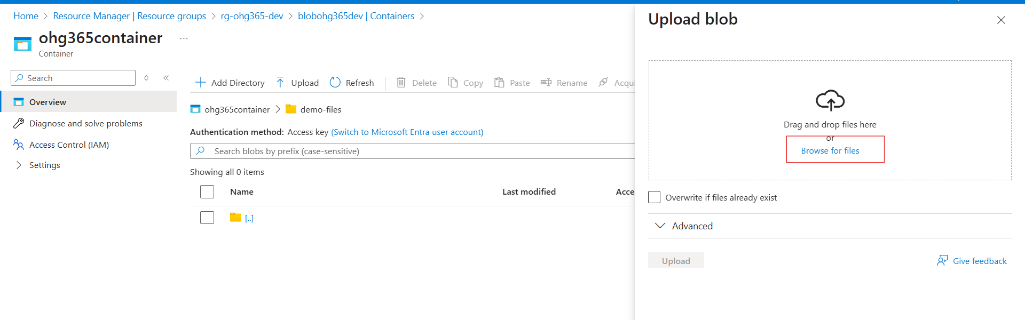

Choose the file here, and then click the Open button.

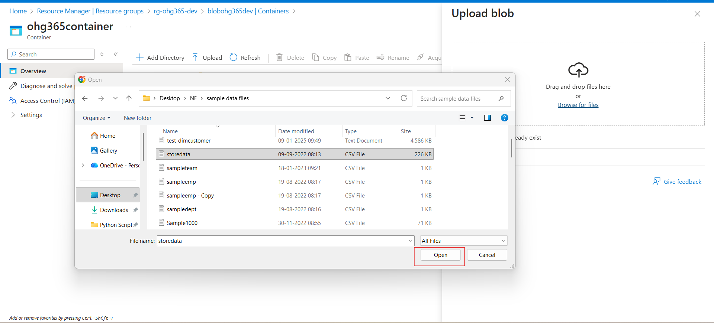

Finally, click on the Upload option here.

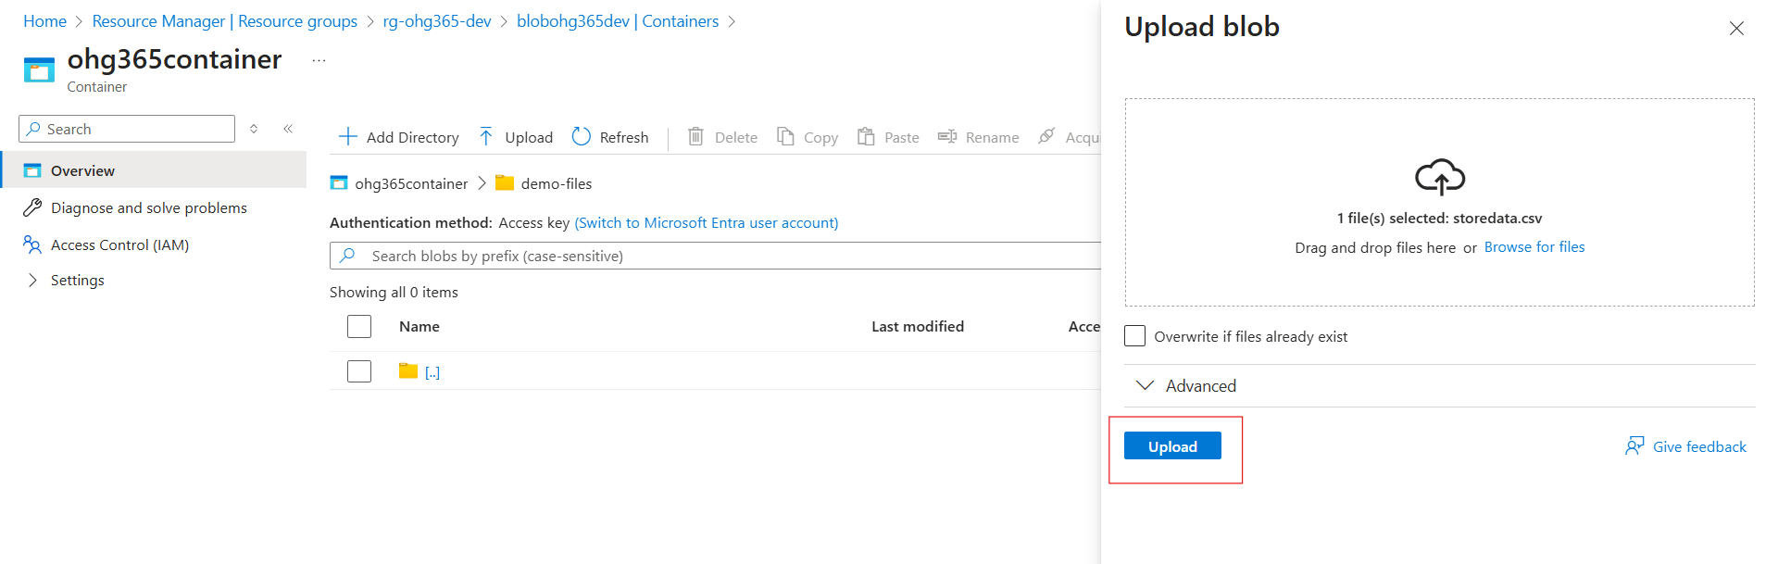

After clicking the Upload option, the file will appear in the list in the Overview page.

